**Windows vs Mac code to execute Cypress test inside docker**

**For WINDOWS**-->Execute all the commands mentioned below in the***command prompt***

1. To check if Docker container is running use command docker ps -a
2. Command to execute test - **docker run -it -v "%cd%":/e2e -w /e2e --entrypoint=cypress cypress/included:latest run**
3. Instead of cypress/included:latest should use the cypress version installed in your machine. For example if the cypress version = 12.12.0 --> Then the command should contain cypress/included:12.12.0

**For MAC**-->Execute all the commands mentioned below in the***terminal***

1. To check if Docker container is running use command docker ps -a
2. Command to execute test  - docker run -it -v $PWD:/e2e -w /e2e --entrypoint=cypress cypress/included:latest run
3. Instead of cypress/included:latest should use the cypress version installed in your machine. For example if the cypress version = 12.12.0 --> Then the command should contain cypress/included:12.12.0

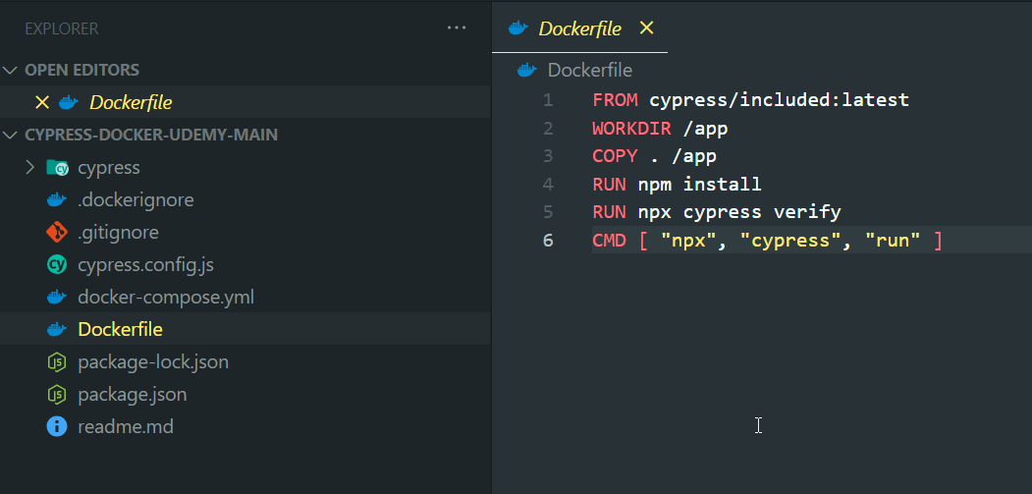

Volume mapping needed for brining the videos and SS out from docker container